

**PONDICHERRY UNIVERISTY**

**Department of  
Computer Science**

M.Sc. 1st Year

**University Counselling for Engineering colleges**

**Sawon Bhattacharya**

19370045

**Rajarsi Saha**

19370037

**Aarko Datta**

19370001

**Introduction**

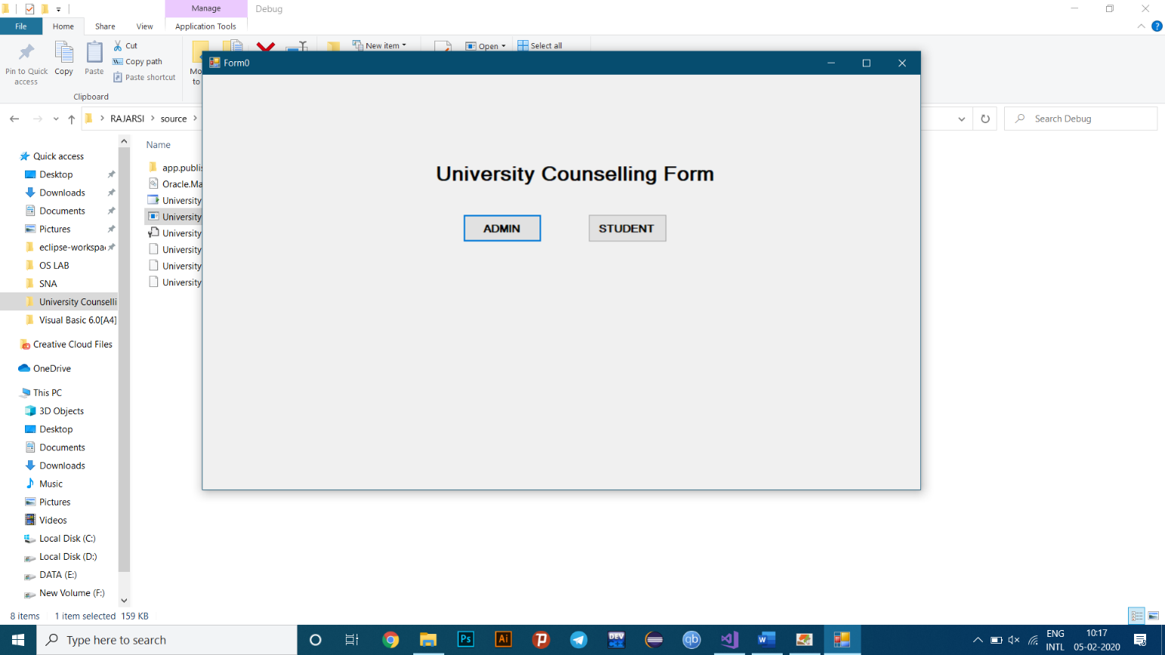This project is mainly based on the creation of a University counselling form for an Engineering College connected to an Oracle database as the back end and windows forms as the front end. This project will help students to fill up registration form for counselling purposes and also allow the admin to view all the data upon using correct login credentials.

**Fig 1: Initial page**

**Software and Tools used:**

1. **Visual Studio 2017 with .NET framework 4.6.1**  
   - used to create Windows forms
2. **Oracle Database Desktop class 12c**  
   - used to create an Oracle database
3. **ODP.NET Managed Driver**  
   - used to create a database connection to the windows forms
4. **EDraw Max**  
   - used to create the ER Diagram

**System requirements:**

1. **Visual Studio 2017 with .NET framework 4.6.1**

**Supported Operating Systems:** Visual Studio 2017 will install and run on the following operating systems:

* Windows 10 version 1507 or higher: Home, Professional, Education, and Enterprise (LTSC and S are not supported)
* Windows Server 2016: Standard and Datacentre
* Windows 8.1 (with Update 2919355): Core, Professional, and Enterprise
* Windows Server 2012 R2 (with Update 2919355): Essentials, Standard, Datacentre
* Windows 7 SP1 (with latest Windows Updates): Home Premium, Professional, Enterprise, Ultimate

**Hardware:**

* 1.8 GHz or faster processor. Dual-core or better recommended
* 2 GB of RAM; 4 GB of RAM recommended (2.5 GB minimum if running on a virtual machine)
* Hard disk space: up to 130 GB of available space, depending on features installed; typical installations require 20-50 GB of free space.
* Hard disk speed: to improve performance, install Windows and Visual Studio on a solid-state drive (SSD).
* Video card that supports a minimum display resolution of 720p (1280 by 720); Visual Studio will work best at a resolution of WXGA (1366 by 768) or higher.

**Additional Requirements:**

* .NET Framework 4.5.2 or above is required to **install** Visual Studio. Visual Studio requires .NET Framework 4.7.2 to run, but this will be installed during setup.

1. **Oracle Database Desktop class 12c**

**Operating system general requirements:** Oracle Database for Windows x64 is supported on the following operating system versions:

* Windows 7 x64 - Professional, Enterprise, and Ultimate editions
* Windows 8 x64 and Windows 8.1 x64 - Pro and Enterprise editions
* Windows 8.1 x64 - Pro and Enterprise editions
* Windows 10 x64 - Pro, Enterprise, and Education editions
* Windows Server 2012 x64 - Standard, Datacentre, Essentials, and Foundation editions
* Windows Server 2012 R2 x64 - Standard, Datacentre, Essentials, and Foundation editions
* Windows Server 2016 x64 - Standard, Datacentre, and Essentials editions

**System Architecture: Processor:** AMD64 and Intel EM64T

**Physical memory (RAM):** 2 GB minimum

**Virtual memory (swap):**

* If physical memory is between 2 GB and 16 GB, then set virtual memory to 1 time the size of the RAM
* If physical memory is more than 16 GB, then set virtual memory to 16 GB

**Disk space:**

* Typical Install Type total: **10 GB**
* Advanced Install Types total: **10 GB**

**Video adapter:** 256 colours

**Screen Resolution:** 1024 X 768 minimum

**Algorithm:**

1. Start
2. Create new database schema
3. Create tables according to the schema using SQL in Oracle
4. Create application for University counselling using software like Visual Studio.
5. Connect University database to windows application using ODP.NET Managed Driver
6. Run application and fill data
7. View data
8. Stop

The detailed explanation of how the entire process was done is given throughout the document in portions with proper data and images wherever needed.

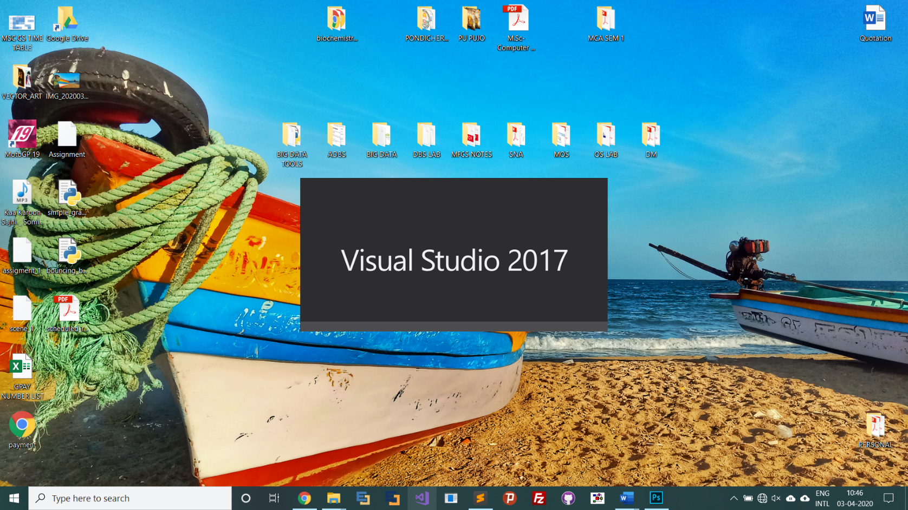

**Fig 2: Visual Studio 2017 Welcome Page**

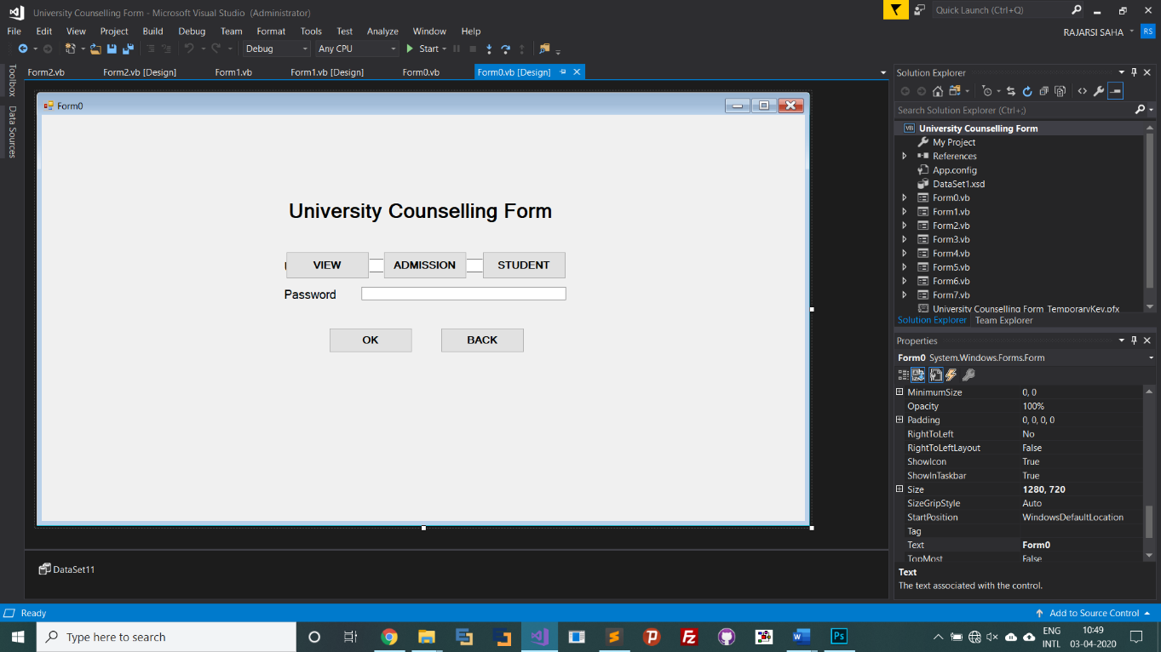

**Fig 3: Windows Form**

**Front end**

The front end has to sections to be opted from:

1. **The Student section**
2. **The Admin section**

**Student Section**

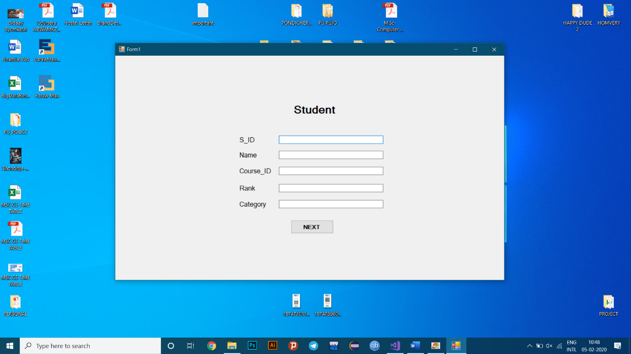The **Student section** can be accessed by anyone to fill up his/her counselling form. There are 6 forms to be filled, all of which are nicely segregated and easy to use.

**Fig 4: Student section**

After filling up all the six forms correctly, a dialouge box will apper on the screen.That will display the message that student has successfully registered.

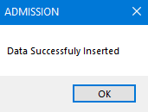

**Fig 5: Student Section**

**Admin Section**

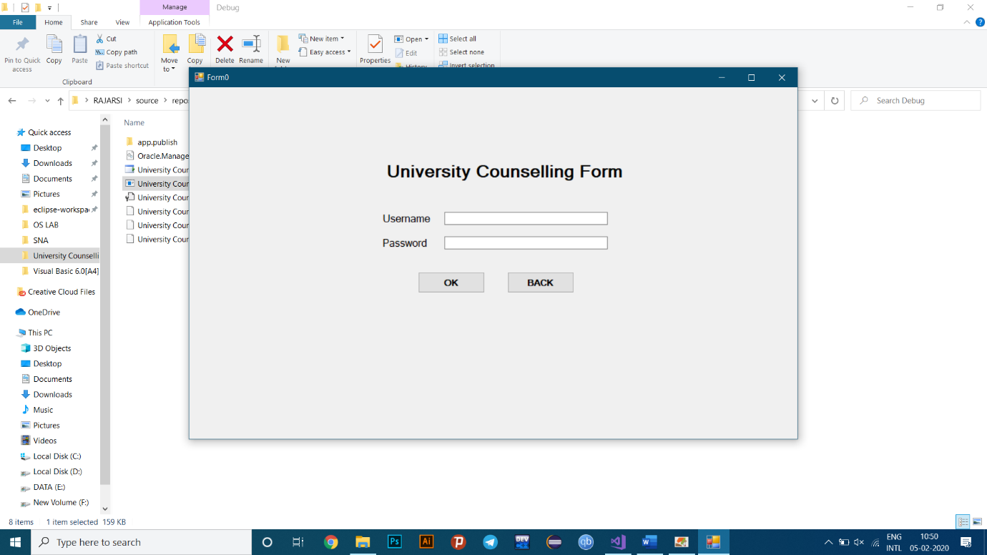The **Admin section** has a login page. Upon giving correct login credentials, the admin can view the entire database including all the tables that has been filled by a student.

**Fig 6: Admin Section**

After log in, a form will appear on the screen through which Admin can see all the details of each student.

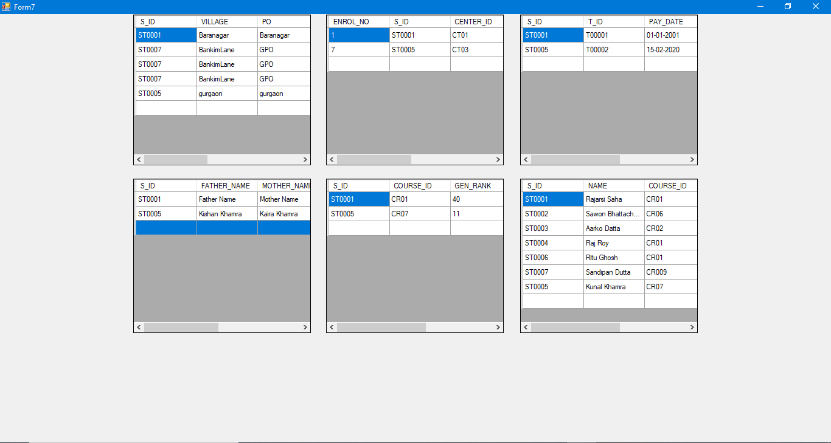 **Fig 7: Admin View on Student Details**

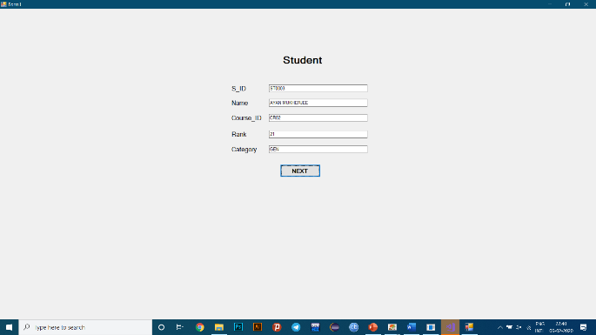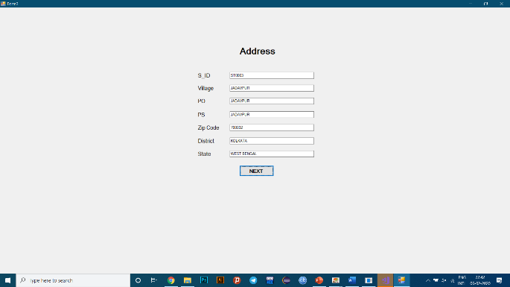**Sequence of windows**

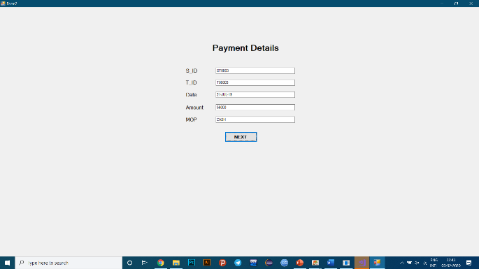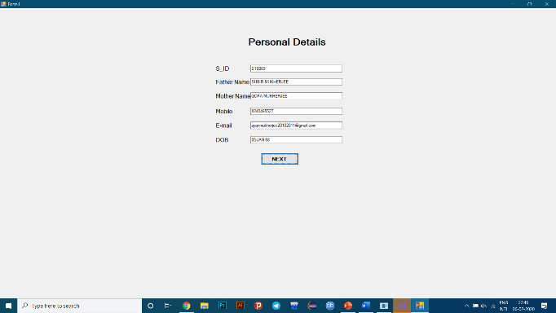**Fig 8: Student form Fig 9: Address form**

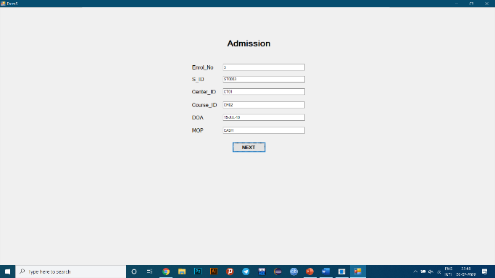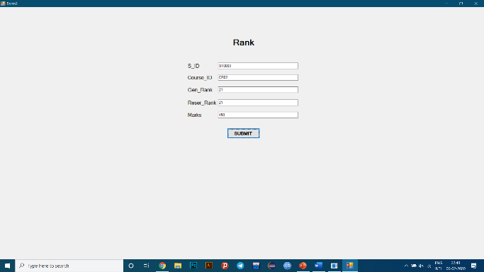 **Fig 10: Payment details form Fig 11: Personal details form**

**Fig 12: Admission form Fig 13: Rank form**

**Back end**

The back end has to sections to be opted from:

1. **ER diagram**
2. **Schema**

**ER diagram**

An **entity-relationship diagram (ERD)** is a data modelling technique that graphically illustrates an information system’s entities and the relationships between those entities.

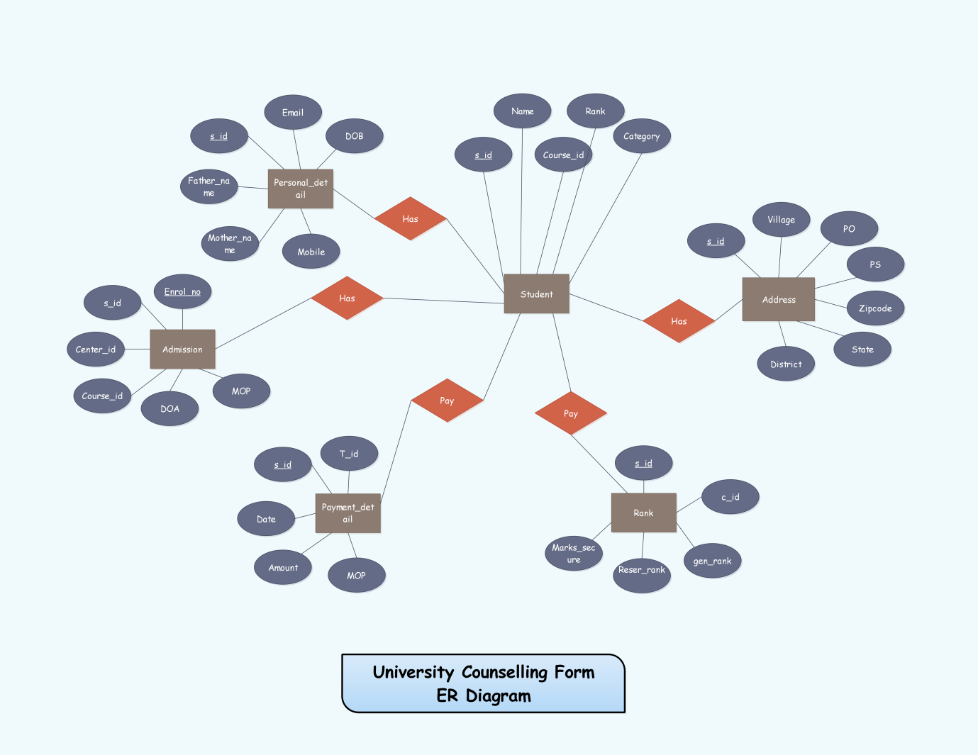

**Fig 14: University Counselling Form ER Diagram**

Here the Student table is the main table. Other tables like Personal details, Address, Rank, Payment details are connected with Student table.

**Schema**

A **database schema** is the skeleton structure that represents the logical view of the entire database. It defines how the data is organized and how the relations among them are associated. It formulates all the constraints that are to be applied on the data.

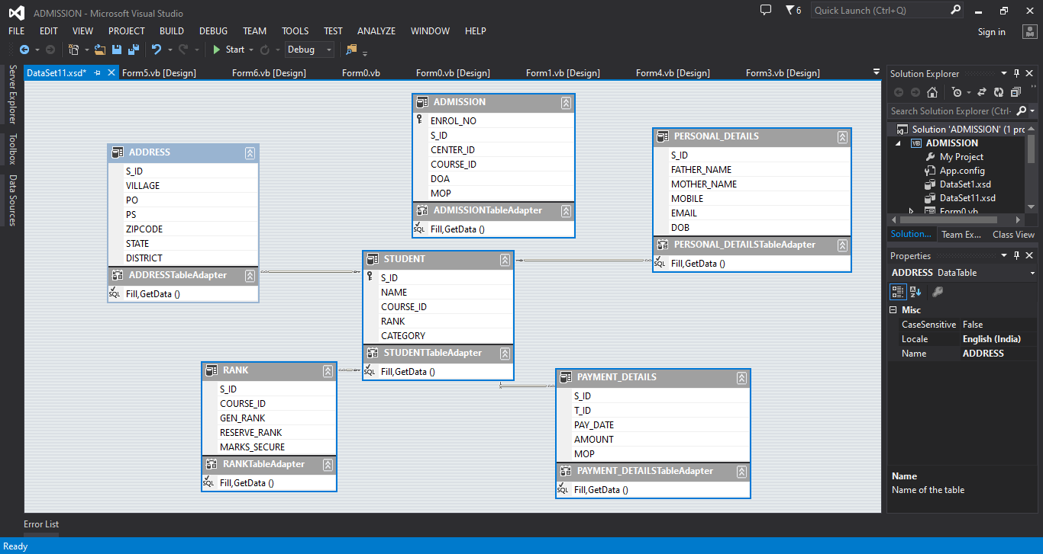

**Fig 15: University Counselling Form Schema**

Here, in the University Counselling Form database **Student** table has the primary key **S_ID**. This **S_ID** is the foreign key in the following tables:

1. **Address**
2. **Personal details**
3. **Rank**
4. **Payment details**

The **Admission** table has its own primary key called **ENROL_NO.** This table is not connected to any other table of the database.

**Terminologies used in the above project are:**

1. **Primary Key**

A **primary key** is a field in a table which uniquely identifies each row/record in a database table. **Primary keys** must contain unique values. A **primary key** column cannot have NULL values. A table can have only one **primary key**, which may consist of single or multiple fields.

1. **Foreign Key**

A **foreign key** is a column or group of columns in a relational database table that provides a link between data in two tables. It acts as a cross-reference between tables because it references the primary key of another table, thereby establishing a link between them.

**Few related definitions:**

**Database:**

A **database** is an organized collection of data, generally stored and accessed electronically from a computer system. Where databases are more complex, they are often developed using formal design and modeling techniques.

**Database Management System (DBMS):**

**The database management system (DBMS)** is the software that interacts with end users, applications, and the database itself to capture and analyse the data. The DBMS software additionally encompasses the core facilities provided to administer the database.

**Fig 16: Oracle 12c database**

The sum total of the database, the DBMS and the associated applications can be referred to as a "database system". Often the term "database" is also used to loosely refer to any of the DBMS, the database system or an application associated with the database.

**Windows Forms:**

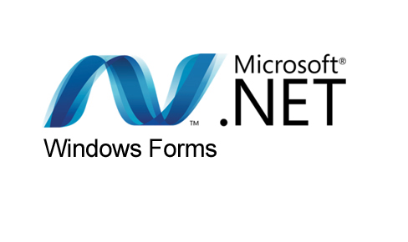**Windows Forms (WinForms)** is a [graphical](https://en.wikipedia.org/wiki/Graphical_user_interface) (GUI) [class library](https://en.wikipedia.org/wiki/Library_(computing)) included as a part of Microsoft [.NET Framework](https://en.wikipedia.org/wiki/.NET_Framework) or Mono Framework, providing a platform to write rich client applications for desktop, laptop, and tablet PCs. While it is seen as a replacement for the earlier and more complex C++ based Microsoft Foundation Class Library, it does not offer a comparable paradigm and only acts as a platform for the user interface tier in a [multi-tier](https://en.wikipedia.org/wiki/Multitier_architecture) solution.

**Fig 17: Microsoft .NET Windows form**

At the Microsoft Connect event on December 4, 2018, [Microsoft](https://en.wikipedia.org/wiki/Microsoft) announced releasing Windows Forms as an open source project on GitHub. It is released under the MIT License. With this release, Windows Forms has become available for projects targeting the .NET Core framework. However, the framework is still available only on the Windows platform, and Mono's incomplete implementation of WinForms remains the only cross-platform implementation.

**References:**

1. **https://www.tutorialspoint.com/sql/sql-primary-key.htm**
2. **https://www.techopedia.com/definition/7272/foreign-key**
3. **https://www.tutorialspoint.com/dbms/dbms_data_schemas.htm**
4. **https://www.techopedia.com/definition/1200/entity-relationship-diagram-erd**
5. **https://en.wikipedia.org/wiki/Database**
6. **https://en.wikipedia.org/wiki/Windows_Forms**